**Operators in Java**

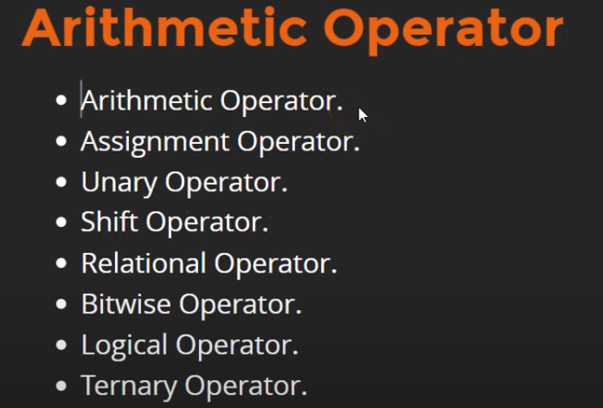

**Unary Operator:**

**++** (++a – Pre-Increment, a++ – Post-Increment)

**--** (++a – Pre-Decrement, a++ – Post-Decrement)

**~** (tilt Operator) – This increment the value by 1 and put (-ve) before the value.   
Ex:

a = 10;  
system.out.println(~a);  
Output: -11